**Farming Portal: Web Based Farming Assistance Services**

**(Removing the Middlemen in the Agriculture Business)**

**Aviral Jaiswal Himanshu Singh Chauhan**

**Department of CSE Department of CSE**

**Shri Ramswaroop Memorial College Shri Ramswaroop Memorial College**

[aviraljaiswal2003@gmail.com](mailto:%20%20%20%20aviraljaiswal2003@gmail.com) [himanshu8564.hs@gmail.com](mailto:himanshu8564.hs@gmail.com)

**Er. Sarika Singh Er. Abhishek Dubey**

**Guided By Guided By**

**Shri Ramswaroop Memorial College Shri Ramswaroop Memorial College**

[sarikasingh2494@gmail.com](mailto:sarikasingh2494@gmail.com) [abhishekdubey.cs@srmcem.ac.in](mailto:abhishekdubey.cs@srmcem.ac.in)

**Abstract:** Information and Communication Technologies (ICTs) have greatly simplified modern life and transformed multiple sectors, including education, banking, healthcare, and e-commerce. In agriculture, ICTs can empower farmers by increasing productivity and profits. This project aims to integrate ICT-based solutions into the agricultural supply chain, allowing consumers to buy directly from farms, ensuring farmers receive fair profits. In India, traditional supply chains involve multiple intermediaries, reducing farmers' earnings while benefiting middlemen. This paper presents **"Farming Portal,"** a web-based system providing farmers with essential information on crops, diseases, market prices, and government schemes. Additionally, it facilitates direct selling of farm produce and purchasing of farming materials, benefiting not only farmers but also agricultural businesses and agencies.

***Keywords:*** Farmer, Admin, Customer.

1. **INTRODUCTION**

Agriculture is a cornerstone of India's economy, with farmers playing a vital role in ensuring food security. As the primary producers of the food we consume, they are essential to society. However, many farmers struggle financially due to the dominance of middlemen who take a significant share of the profits, leaving them with inadequate earnings.

With the rapid advancement of technology, digital solutions have transformed various aspects of daily life, from shopping and bill payments to work management. This project aims to leverage technology to bridge the gap between farmers and consumers, enabling direct transactions that eliminate unnecessary intermediaries. By creating a platform where consumers can purchase fresh produce directly from farmers, we can help ensure fair compensation for their hard work while offering buyers fresh, quality products at competitive prices. This initiative has the potential to disrupt the traditional supply chain, fostering a more sustainable and equitable agricultural economy.

1. **LITERATURE SURVEY**

The agricultural sector, a key pillar of the global economy, has experienced significant advancements due to the integration of digital technologies and online services [3]. This literature survey explores key studies, research findings, and trends related to farming assistance web services and the elimination of intermediaries in agriculture.

**1. Historical Role of Intermediaries in Agriculture**

Traditionally, intermediaries have played a crucial role in connecting farmers to markets and resources. Williamson (1979) highlighted their importance in minimizing transaction costs. However, studies by Reardon et al. (1992) and Tilman et al. [4] discuss the inefficiencies and exploitative practices often associated with middlemen.

**2. Advantages of Eliminating Middlemen**

Research has underscored the benefits of removing intermediaries from the agricultural supply chain. Swinnen (2007) argues that direct farmer-to-buyer interactions lead to higher farmer profits and price transparency. Additionally, studies by Babcock [5] and Clemens (2004) indicate that cutting out middlemen significantly reduces transaction costs.

**3. Challenges and Concerns**

Despite its advantages, bypassing intermediaries presents challenges. A World Bank (2015) study emphasizes the digital literacy and internet accessibility barriers faced by farmers in developing nations. Additionally, scholars like Smith et al. (2018) [6] have raised concerns over privacy and data security in web-based agricultural services.

**4. Case Studies of Successful Implementation**

Several case studies illustrate the successful application of digital farming assistance. Kumar and Qureshi (2018) analyzed AgroStar in India, where a mobile app [7] connects farmers with agricultural inputs and advisory services. Similarly, the U.S.-based FarmLogs platform, as discussed by Lowenberg-DeBoer and Erickson (2018), showcases the advantages of data-driven farm management [8].  
"Design of Web Portal for E-Trading for Farmers" by Vishi Purushottam Paliwal et al. explores the development of a web portal aimed at enabling direct e-trading between farmers and buyers. The authors [9] also stress the importance of farmer education and training in e-trading adoption.

**5. Future Prospects and Policy Considerations**

The evolution of web-based farming assistance continues to be a subject of research. Hobbs (2018) discusses the growing role of AI and machine learning in agriculture, while Marette and Messéan (2017) highlight regulatory and policy implications.  
A study published on IEEE Xplore, "A Study of Blockchain Technology in Farmer’s Portal," explores blockchain’s transformative potential in agricultural transactions [10]. The authors propose a blockchain-based portal integrating smart contracts, digital identities, and secure data storage, emphasizing its potential to enhance efficiency, reduce costs, and improve data security and privacy.

**Conclusion**

This literature survey underscores the complex shift toward web-based farming assistance and the removal of intermediaries. While there are significant benefits for farmers, various challenges must be addressed. As agriculture continues to evolve, ongoing research remains essential for understanding these transitions and guiding informed policy decisions.

1. **PROPOSED SYSTEM**

The system proposed by us aims to streamline the marketing of agricultural products for farmers, benefiting both farmers and buyers alike. The system is developed as a web application using HTML, CSS, JavaScript, Python, and MySQL, featuring interfaces tailored for both large and small screens. Both the farmer and end user need to log in to the system by providing all necessary details to access its features.

This system is a website as well as a mobile application. Farmers can use the system directly by entering the URL of our website or just by opening the application. At this stage, users will receive fundamental farming-related information. If they wish to engage in selling or purchasing, such as farmers intending to sell their produce, registration through the provided form and subsequent login are mandatory. Similarly, for purchasing, registration and login procedures are also required.

Apart from farmers, two types of people can also benefit from this system:

1. Consumer
2. Supplier

The information provided by the farmer regarding their products will be stored in the database. All details of the farmer, including their product, price, location, and contact number, will be showcased to the end user during the purchase process. Additionally, this system offers multi-language support to enhance user-friendliness and accessibility across various local languages.

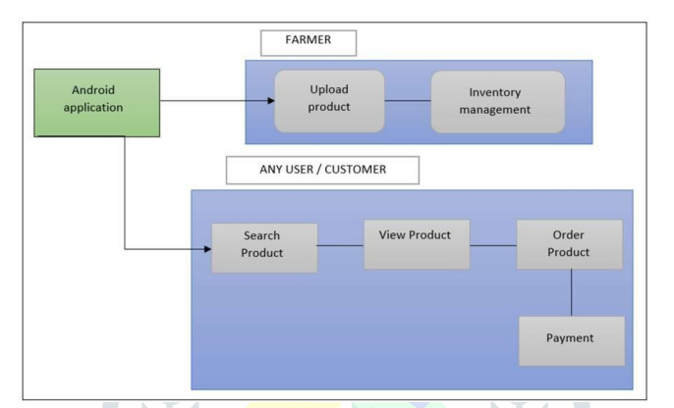

**Figure 1: The Block Diagram**

In Figure 1. the block diagram of the proposed system is explained. The system involves three actors: admin, farmer, and consumer. Upon successful registration, both the farmer and the buyer will receive a username and password. To input product information, the farmer must log in with the correct credentials. The customer can select any product available that they need and place an order. All the current news and updates related to various products or agricultural fairs going on would be displayed on the portal. Additionally, the portal will provide a list of current market rates for specific products. Thus, this portal will serve as a benchmark for all producers to enhance their profits, consequently leading to an uplift in our country's economy.

1. **METHODOLOGY**

4.1 The Customer/User:

Customer module contains the following:

• Customer details

• Post Advertisement

• Crop Received

• Make Payments

4.2 The Farmer:

Farmer module contains the following:

• Complaint Page

• Complaint Status

• Farming Tips

• Crop Advertisement Details

• Sell Crop

• Sell Crop Details

• Edit Farmer Details

4.3 Admin:

Admin module contains:

• View Complaints

• Farming Tip

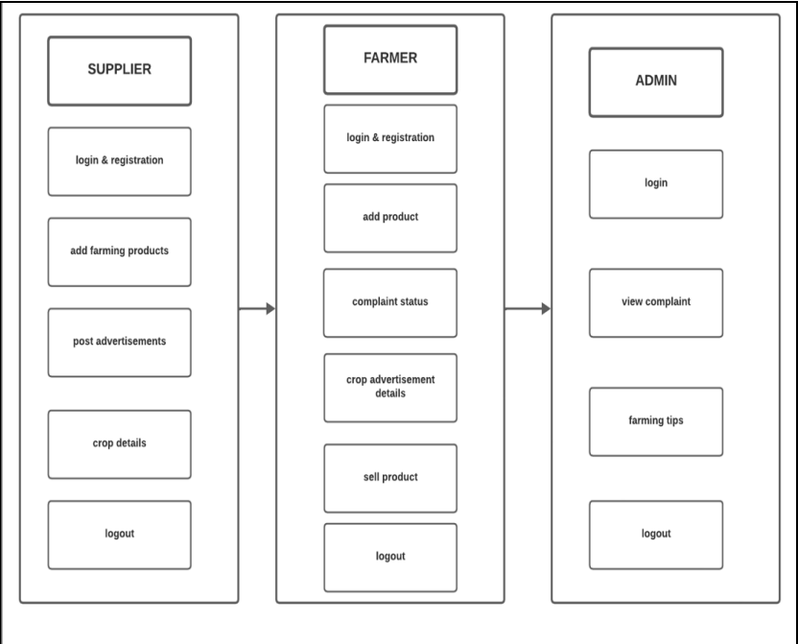

**Figure 2: Module Description**

1. **MODEL AND ANALYSIS**

5.1 Login Page

Secure access for farmers, buyers, and admins via email/phone login. Features include password recovery, role-based access, and data encryption. Users are directed to a personalized dashboard for farming resources and e-trading.

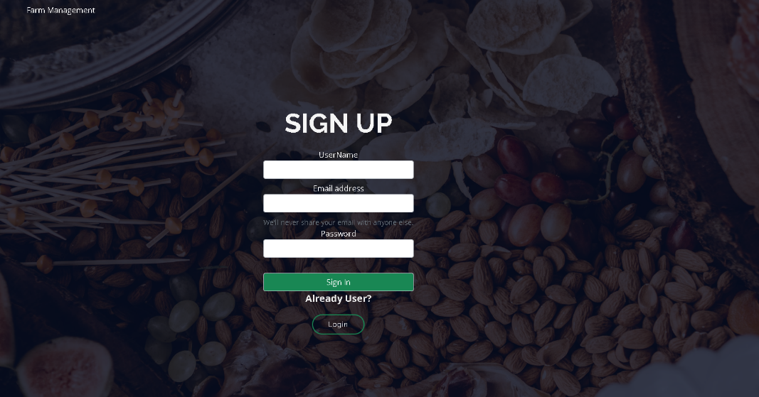

**Figure 3: Login Page**

5.2 Farmer Registration

Farmers can easily sign up by providing basic details like name, contact, location, and farm type. The process includes identity verification and secure login setup. Once registered, farmers gain access to e-trading, resources, and buyer connections.

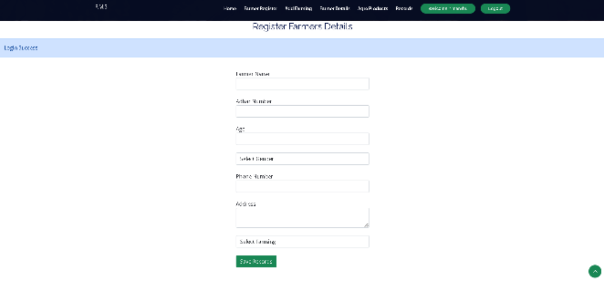

5.3 Product or inventory showcase

The Product Showcase section allows farmers to display their agricultural produce, equipment, and related products to potential buyers. Each listing includes high-quality images, descriptions, pricing, and availability. Buyers can browse, compare, and directly connect with sellers for seamless transactions, ensuring fair trade and better market reach for farmers.

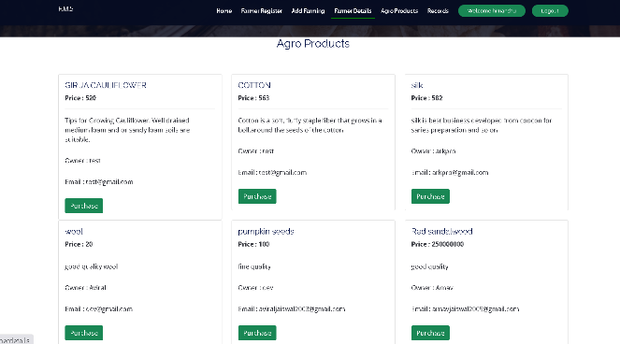

5.4 Record Section

The Record Section helps farmers track transactions, inventory, and sales history. It provides organized data for better farm management and decision-making.

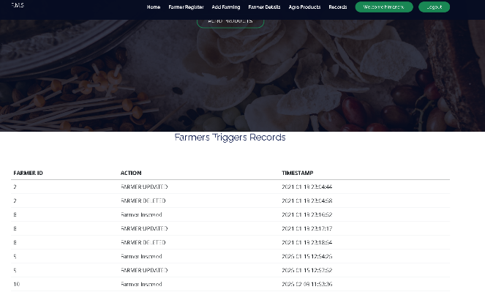

5.5 User Interface

The User Interface is designed to be user-friendly, intuitive, and accessible for farmers and buyers. It features a clean layout, easy navigation, and well-organized categories for seamless browsing. With multilingual support and responsive design, users can access the platform effortlessly across devices.

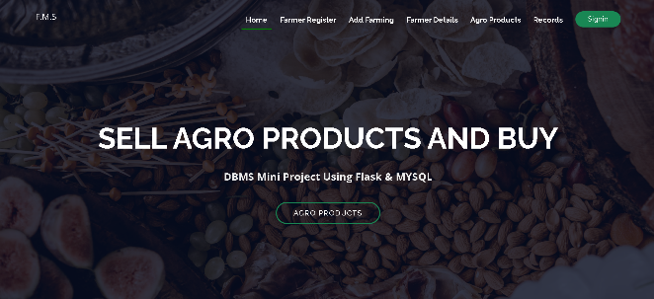

1. **Future Scope**

• Integration with supply chain management system can help farmers streamline the process from field to market. This includes features like crop tracking, inventory management and predictive analysis for market demand.

• As technology continues to advance, this application can increasingly leverage IoT device, drone and sensor to provide real time data on soil health, weather condition, crop growth and pest infestations. This will allow farmers to make data driven decisions to optimize resources usage and increase crop yields.

• Implementing blockchain technology can ensure the traceability and transparency of agricultural products, helping consumers verify the authenticity and origin of their food.

• Collaborating with agricultural research institutions, government agencies, and NGOs can enhance the application's usage and effectiveness. Such partnerships can lead to data sharing, funding opportunities, and policy advocacy.

• The application can incorporate advanced data analytics and artificial intelligence to predict crop diseases, optimize irrigation schedules, and suggest optimal planting times based on historical data and weather forecasts. Machine learning models can also help in identifying pest patterns and recommending suitable interventions.

1. **SPECIFICATIONS**

6.1. Advantages of Farming Assistance Services

6.1.1. Farmers can access a wealth of information on various subjects at their fingertips. Informed decisions can result in increased productivity and profitability.

6.1.2. The farmers can connect with potential buyers, expanding their market reach and increasing sales opportunities, which can lead to better income and market stability.

6.1.3. Farmers can advertise their crops to showcase their products to potential suppliers.

6.1.4. The farmers can sell their products directly to the supplier without the involvement of the mediators.

6.1.5. Farmers also have the option to post complaints, which will be addressed by the administration.

6.2 Disadvantages of Farming Assistance Services

6.2.1. Farmers in remote or underserved areas may have limited internet access, hindering their ability to use the application effectively.

6.2.2. Farmers with low literacy levels or who speak languages not supported by the application may struggle to use it effectively.

6.2.3. The cost of developing, deploying, and maintaining such a system, including hardware, software, and support, may be a barrier to widespread adoption.

6.2.4. The digital divide can exacerbate disparities, as farmers with limited access to technology may be left behind.

6.2.5. Too much data without proper guidance can lead to fraud in some cases, also making it challenging to extract actionable insights.

1. **CONCLUSION**

Hence, the system proposed in this paper connects nearby local farmers to customers from urban and rural areas. This application is reliable and user-friendly. Through the portal, fresh products can be acquired, allowing people to explore various parts of their surrounding villages and purchase items directly from farmers. As a result, expenses for both farmers and customers are reduced, leading to increased profits. The conventional method involves adding an intermediary between the buyer and the farmer, resulting in farmers not earning better rates and much of the profit being taken by intermediary parties. Therefore, the system transitions from the traditionally used e-commerce system to a newly and highly effective system, enabling farmers to live with pride.

1. **REFERENCES**
   1. Manav Singhal, Kshitij Verma, Anupam Shukla, “Krishi Ville - Android based solution for Indian agriculture”. 2011 Fifth IEEE International Conference on Advanced Telecommunication Systems and Networks (ANTS), 18-21 Dec. 2011, Bangalore, India.
   2. Shankar M. Patil, Monika Jadhav, Vishakha Jagtap, “Android Application for Farmers”, International Research Journal of Engineering and Technology, volume 6, issue 4, 2019, 4200-4202p.
   3. Abishek A. G., Bharathwaj M., Bhagyalaksh--miL.“Agriculture Marketing Using Web and Mobile Based Technologies”, 2016 IEEE International Technological Innovations in ICT For Agriculture and Rural Development (TIAR 2016).
   4. D. Tilman C. Balzer J. Hill B.L. Befort Global food demand and the sustainable intensification of agriculture Proceedings of the National Academy of Sciences 108 50 2011 20260 20264
   5. Babcock B 2013 *Cutting Waste in the Crop Insurance Program* ed N Bruzelius (Washington, DC: Environmental Working Group) ( <http://cdn.ewg.org/sites/default/files/u118/2013%20Cutting%20Crop%20Insurance%20Waste_.pdf?_ga=1.110206349.96985284.1437058644>)
   6. <https://www.researchgate.net/publication/321683848_Learner_Autonomy_in_Developing_Countries>
   7. Md Iqbal, Vimal Kumar and Vijay Kumar Sharma. Krishi Portal: Web Based Farmer Help Assistance. International Journal of Advanced Science and Technology Vol. 29, No. 6, (2020), pp. 4783 – 4786
   8. Abishek, A. G., Bharathwaj, M., & Bhagyalakshmi, L. (2016). Agriculture marketing using web and mobile based technologies. 2016 IEEE Technological Innovations in ICT for Agriculture and Rural Development (TIAR). doi:10.1109/tiar.2016.7801211
   9. Vishi Purushottam Paliwal et al, “Design of Web Portal for ETrading for Farmers”, International Journal on Future Revolution in Computer Science and Communication Engineering, vol. 4, pp. 220-222, 2018.
   10. Specification for security management systems for the supply chain, ISO 28000-2007, 2007. [Online]. Available: http://www.iso.org/iso/ catalogue_detail?csnumber=44641 [7] C. Speier, J. M. Whipple, D. J. Closs, and M. D. Voss, “Global supply chain design considerations: Mitigating product safety and security risks,” J. Oper. Manage., vol. 29, pp. 721 736, 2011.
   11. Shital Chaudhari, Vaishnavi Mhatre, PoojaPatil, Sandeep Chavan, “Smart Farm Application: A Modern Farming Technique Using Android Application”, IJRET, Feb 2018.